### Create The Travel Approval App

**Create the Travel Approval app:**

* From Setup, enter App Manager in the Quick Find and select App Manager.
* Click New Lightning App
* Enter **Travel Approval** as the App Name, then click Next
* Under App Options, leave the default selections and click Next.
* Under Utility Items, leave as is and click Next.
* From  Available  Items,  select **Department,  Employee  Detail,  Expense,  Expense  Items,  Travel Approval, Reports, and Dashboards** and move them to Selected Items. Click Next.
* From  Available  Profiles,  select  System  Administrator  and  move  it  to  Selected  Profiles.Click  Save & Finish.

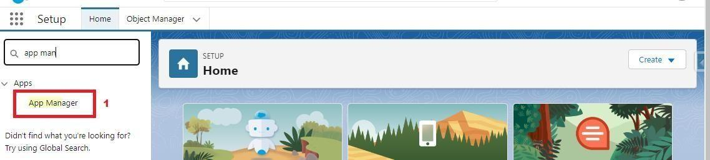

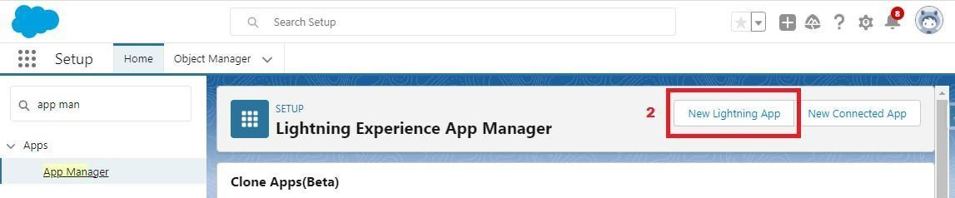

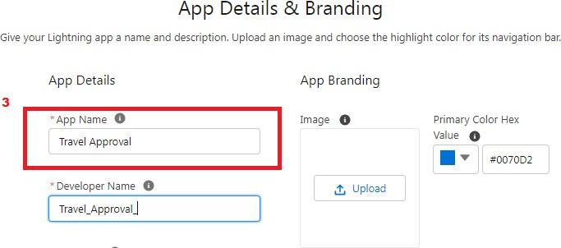

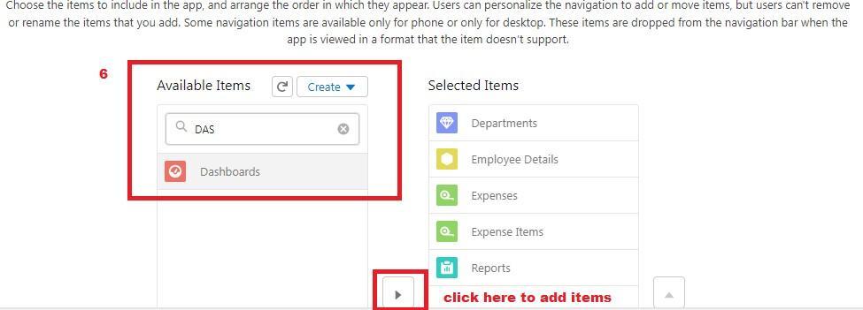

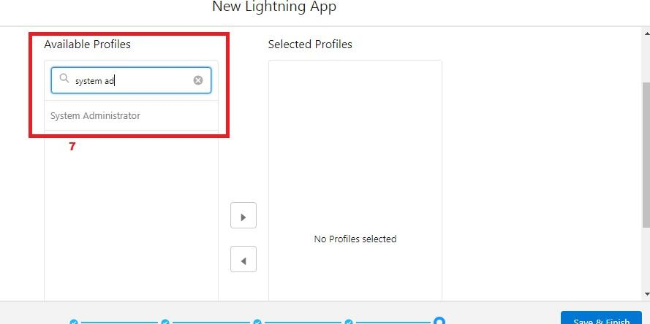

 To verify your changes, click the App Launcher, type **Travel Approval** and select the **Travel Approval** app.

 Note:

1. App Launcher-Displays available apps.
2. App Name-Displays the current selected app.